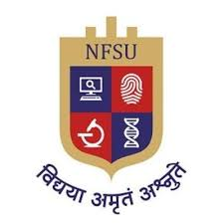

**National Forensics Sciences University**

**School of Cyber Security and Digital Forensics**

**M.Tech Artificial Intelligence and Data Science (Specialization in Cyber Security)**

**Network Security and Forensics**

**Practical 1**

**Session 2024-25**

**Semester 1**

|  |  |
| --- | --- |
| **Submitted To:-** | **Submitted By:-** |
| Dr. Vijeta Khare | Pratham Badge |